SDG Advocate Training 2020
Become one of Ireland’s SDG Advocates!
Closing Date for Application: 25th February 2020

Please return completed applications to deborah@developmentperspectives.ie or by post to Development Perspectives, 10 North Quay, Drogheda, Co. Louth.

Personal Information

Full Name:
Date of Birth:
Postal Address
Phone number:
Email Address*:

- Please provide a permanent email address, as this will be our main source of contact for you.

1. What area of work or study are you involved in at the moment?

Motivations
2. Please outline your motivation for wanting to participate in this project?

3. What individual skills do you envisage yourself contributing to the project?

4. Please describe what “Active Citizenship” means to you?

5. What would you like to gain as a result of this project?

6. What are your plans for involving the experience and learning gathered on this training project into current / future work, study or activity?

Other information
1. Will you be able to commit to the entire project (Phase 1, Phase 2, Phase 3)?

Yes No

More information:

2. Please provide details of any special requirements you might have (Mobility, Medical conditions, Allergies, Diets, etc)

3. Do you have any pre-existing medical conditions?

Yes No

If yes, a doctor’s certificate will be requested to travel.
 | Website |  | College
 | Facebook |  | Through a friend
 | Twitter
 | Other, please specify:

4. Please indicate your preferred overseas project dates?

Vietnam, June 2020 Tanzania, June / July 2020

5. Please provide details of a referee (Academic or Professional)

6. Where did you hear about the SDG Advocate Training?
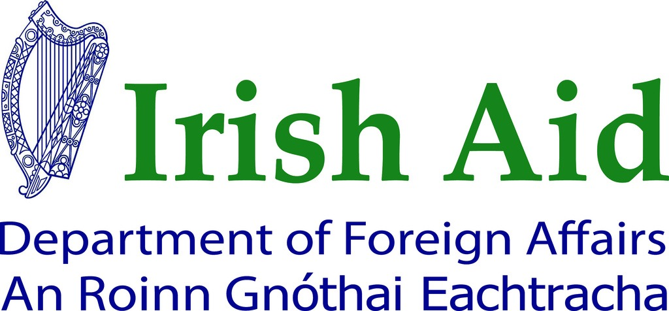
This project was funded by the Department of Foreign Affairs and Trade (DFAT). The content of this communication represents the views of the author only and do not necessarily represent or reflect DFAT policy.

