SDG Advocate Training 2021
Become one of Ireland’s SDG Advocates!
Closing Date for Application: 26th February 2021

Please return completed applications to mog@developmentperspectives.ie

Personal Information

Full Name:
Date of Birth:
Postal Address

Please note that all applicants must have a postal address on the island of Ireland to qualify.
Phone number:
Email Address*:

- Please provide a permanent email address, as this will be our main source of contact for you.

1. What area of work or study are you involved in at the moment?

2. Please outline any previous or current involvement you have in the adult and community education sector?

Motivations

1. Please outline your motivation for wanting to participate in this project?

2. What individual skills do you envisage yourself contributing to the project?

3. Please describe what “Active Citizenship” means to you?

4. What would you like to gain as a result of this project?

5. What are your plans for involving the experience and learning gathered on this training project into current / future work, study or activity?

Other information

1. Will you be able to commit to the entire project?

Yes No

More information:

2. Please provide details of any special requirements you have for attending a residential? (Mobility, Medical conditions, Allergies, Diets, etc)
 | Website |  | College
 | Facebook |  | Through a friend
 | Twitter
 | Other, please specify:

3. Where did you hear about the SDG Advocate Training?

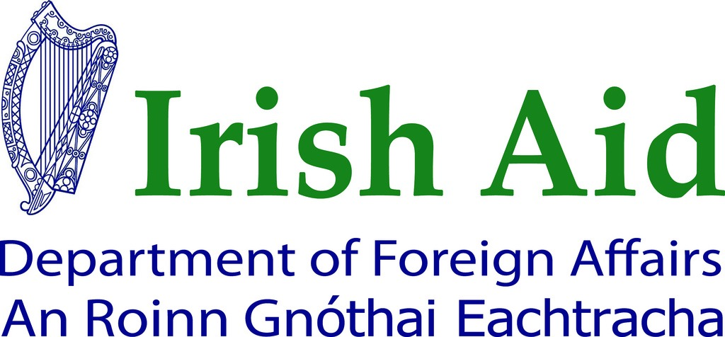
This project was funded by the Department of Foreign Affairs and Trade (DFA). The content of this communication represents the views of the author only and do not necessarily represent or reflect DFA policy.

